HOLY WOMEN COMPANIONS: Miriam and Isadora Duncan
Celebrators of LIFE
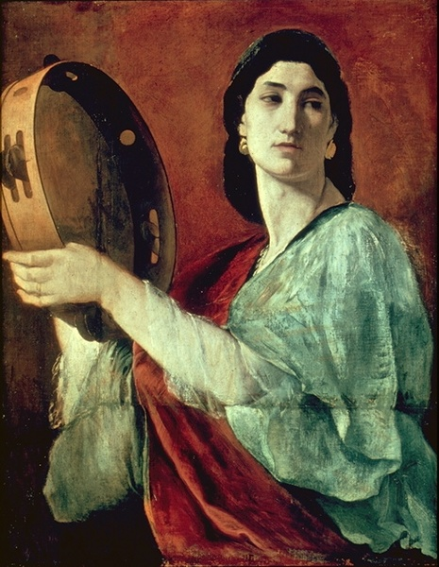
Miriam – Old Testament
One of the few prophetesses in the Bible, Miriam is primarily recognized for the role she played in saving the life of her brother, Moses while the Israelites lived in Exile in Egypt.
After she witnessed Pharaoh’s daughter pull the child out of the river, Miriam offered her mother as a nursemaid. Neither she nor her mother realized the significance that their actions would have on their nation by saving Moses’ life.
After God parted the seas so they could escape Pharoah’s men, Miriam encouraged the other Israelite women to join her in a song of thanksgiving and praise to God for being saved.

“Then the prophet Miriam, took a tambourine in her hand, and with all the women dancing; they sang: Sing to the Lord, for God is gloriously triumphant; horse and chariot have been cast into the sea.” Exodus 15:20
Reflection Questions: Even in the midst of challenge and pain, what helps you to break into song figuratively or literally? How do you engage others in the “song” that is theirs to sing?
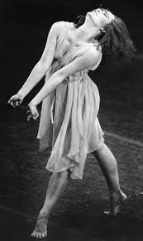
Isadora Duncan (1877-1927)
Angela Isadora Duncan was an American-born dancer and choreographer, who was a pioneer of modern contemporary dance and performed to great acclaim throughout Europe and the US. Born and raised in California, she lived and danced in Western Europe, the US and Soviet Russia from the age of 22. She went on to liberate dance from the confines of the ballet of her time, shedding slippers and corset to combine the use of simple, natural movement with a vibrant musicality that would illuminate the human spirit and its connection to nature.
“You were wild once, don’t let them tame you!” Isadora Duncan
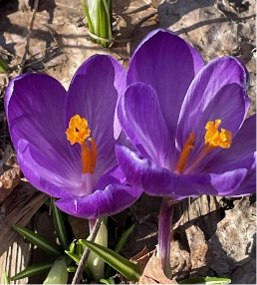
Reflection Questions: What are you sensing within yourself that has been “tamed” and that God’s spirit is urging you to set free? What is the first step?
Prayer: Creator God, may our prayer, our very lives speak of celebration! May our spirits break free even when our limbs are tired and sore or our courage lacking. May we never be too tame when you call us to be bold dance partners in a world so permeated with fear and sadness. Let us dance and sing. Get out the tambourine. May it be so. Amen.

